**STUDENT ATTENDANCE MANAGEMENT SYSTEM USING BARCODE IDENTIFICATION**

**Student Number: 89453**

An information systems documentation report submitted to the Faculty of Information Technology in partial fulfilment of the requirements for the award of a Bachelor’s Degree in Business Information Technology of Strathmore University

November 2018

## Declaration

I declare that this work has not been previously submitted and approved for the award of a Bachelor’s degree by this or any other University. To the best of our knowledge and belief, the proposal contains no material previously published or written by another person except where due reference is made in the proposal itself.

Admission No……………………

Signature………………………

Date………………………

**Approval**

The information systems project proposal of Student Numbers of Candidate was reviewed and approved by:

Supervisor Signature………………………

Date………………………

## Abstract

Strathmore University capture student attendance details using paper sheets. The lecturer uses the data on the paper sheet and transfers the data to the current system. It takes a lot of time to transfer or update student attendance details from paper sheets to the current system.

The proposed system will assist the students to fill the attendance for a particular class using the student ID cards. The proposed system will be fast, accurate and eliminate the use of paper sheets. The proposed system will also eliminate data forging by students for those students who skip classes, hence it will serve as a tool to monitor students that miss classes in order to inform their guardians.

The system will be a web-based application. The web application will be developed using HTML, PHP and CSS programming languages. Data and information will be stored in a database. The Database management system to be used in My Structured query language (MySQL).

**Table of contents**

Declaration i

Abstract ii

Chapter 1 : Introduction 1

1.1 Background 1

1.2 Problem statement 1

1.3 Objectives 2

1.3.1 Main Objectives 2

1.3.2 Specific Objectives 2

1.4 Justification for the study 2

1.5 Scope/Delimitation 2

1.5.1 Scope 2

1.5.2 Limitation 3

Chapter 2 : Literature Review 4

2.1 Introduction 4

2.2 Platforms required for the proposed system 4

2.2.1 Hardware consideration 4

2.2.2 Software considerations 4

2.2 Platforms required for the proposed system 4

2.2.1 Hardware consideration 4

2.2.2 Software considerations 5

2.3 Related Applications to the Attendance Management system 5

2.3.1 Embedded Computer-Based Lecture Attendance Management System 5

2.3.2 Wireless Fingerprint Based College Attendance System Using Zigbee Technology 5

2.4 Proposed system 6

Chapter 3 : Methodology 7

3.1 Introduction 7

3.1.1 Prototyping Model 7

3.1.2 Stages of prototyping 7

3.1.3 Justification for using Prototyping Model 8

3.2 System Design 9

3.2.1 System Architecture 9

3.2.2 Flowchart of the System module 10

3.3 System implementation methods and tools 10

3.4 Deliverables 11

Chapter 4 : System Design and Architecture 12

4.1 Introduction 12

4.2 Requirement Analysis 12

4.2.1 Functional Requirements 12

4.2.2 Non-Functional Requirements 12

4.3 System Designs 13

4.3.1 Use Diagram 13

4.3.2 Sequence Diagram 14

4.3.3 Database Schema 15

4.3.4 Design ERD Diagram 16

4.3.5 Design Class Diagram 16

4.4 Proposed System Architecture 17

Chapter 5 : System Development, implementation and Testing 18

5.1 Introduction 18

5.2 System Development 18

5.3 System Implementation 18

5.3.1 barcode reader 18

5.3.1 Web Application 19

5.4 System Testing 19

5.4.1 Test Environment 20

5.4.2. Test Cases 20

5.4.3 Test results 21

24

27

5.5 System Outcomes 27

Chapter 6 : Conclusion and Recommendation 28

6.1 Conclusion 28

6.2 Recommendations 28

6.3 Future Works 28

APPENDICES 29

APPENDIX 1: Administrator User Manual 29

APPENDIX 2: Student User Manual 32

APPENDIX 3: Lecturer User Manual 34

References 38

**List of Figures**

Figure 2.1 Embedded computer-based lecture attendance system 5

Figure 2.2 General architecture of fingerprint biometric system 6

Figure 3.1 Stages of prototyping 7

Figure 3.2 Architecture of the system 9

Figure 3.3 Proposed System Model 10

Figure 4.1 Student Attendance Management system 13

Figure 4.2 Sequence Diagram 14

Figure 4.3 Database Schema 15

Figure 4.4 Entity Relationship Diagram 16

Figure 4.5Class Diagram 16

Figure 4.6 System Architecture 17

Figure 5.1 Barcode reader android application 18

Figure 5.2 Administrator Homepage 19

Figure 5.3 Test Result for Test ID M1 21

Figure 5.4 Test Result for Test ID M2 22

Figure 5.5 Test Result for Test ID M3 23

Figure 5.6 Test Result for Test ID M4 24

Figure 5.7 Test Result for Test ID M5 25

Figure 5.8 Test Result for Test ID M6 26

Figure 5.9 Test result for Test ID M7 27

**List of Tables**

Table 5.1 Test Environment 20

Table 5.2 Test Cases 21

Table 5.3 Test Result for Test ID M1 21

Table 5.5 Test Result for Test ID M2 22

Table 5.6 Test Result for Test ID M3 23

Table 5.7 Test Result for Test ID M4 24

Table 5.8 Test Result for Test ID M5 25

Table 5.9 Test Result for Test ID M6 25

Table 5.10 Test result for Test ID M7 26

# : Introduction

## 1.1 Background

Most Universities have certain criteria concerning students regarding their attendance in class and examination. In the process of allowing students in Strathmore University to enter the examination room, 67% of the attendance must be met. This brings about the need to have a tool to control student’s attendance details.

Strathmore University has no efficient way to capture student attendance details. Attendance details are captured using paper sheets. The lecturer uses the data on the paper sheet and transfers the data to the current system. This is not efficient as this can be cumbersome to the lecturer as it takes a lot of time to transfer or update student attendance details from paper to the current system.

This project is a solution to some of the problems faced in the current system. For example, knowing students who actually attend class. Students write their signatures on the paper sheet and the signatures can easily be forged for those students did not attended class. Knowing students who actually attend class will be achieved using barcodes from student ID cards which will uniquely identify students. The relationship between the current system and this project is that they are both are concerned in capturing student attendance details and analysis that data.

This project was concerned with capturing student attendance details. The system should be able to allow students to register into the system and fill their attendance details when going to class. The system should use the data collected for data analysis and computation which include calculating attendance in terms of percentage for a particular student. The students should be able to view their attendance details in their accounts. The system will aid the lecturer know the students who missed class and those who attended class on a particular day.

## 1.2 Problem statement

The problem at hand was that student attendance details was captured using paper sheets. In the current attendance system, lectures have to either ask their students to write their names on a piece of paper if their name is not in the system, or they provide a list of enrolled students and ask them to place their signatures on their names. After the data has been collected, the lectures have to transfer that data into the system. This is not efficient because it takes more time and effort to transfer the data into the system for data analysis.

Another problem of using paper sheets is that data forgery can occur very easily. Some students miss classes and ask their friends to sign for them by forging their signatures. It is not easy for a lecturer to know that a student is not in class and that somebody has signed for the absent student. The lecturer does not have time to check who forged signatures for other students. The only way for the lecturer to know that somebody has missed class is to carry out a roll call.

The solution would be to develop a computerized system which uses barcode technology. The barcode in student ID cards should uniquely identify each student. The will solve the problem of data forgery. The proposed system will help lecturer track students and save time of transferring student attendance details from the attendance sheet to the system.

## 1.3 Objectives

### 1.3.1 Main Objectives

The main aim is to develop a web-based application that will capture student attendance details using barcode technology.

### 1.3.2 Specific Objectives

1. To propose a solution to the problem.
2. To test the system into a real working environment.
3. To complete the project within the required time.

## 1.4 Justification for the study

The system will identify students uniquely using student ID cards. Barcodes from student’s ID cards cannot be manipulated like signatures which can be easily be forged by other students for the purpose of missing classes. The system will enable tracking of students in the University. When a student enters class, the student should swipe the ID card on the barcode scanner which mark that a student attended class on a particular date and time. The lecturer will be able to identify students who attended class on a particular day and those who were absent. The proposed system will also assist the lecturer know the actual time the student arrived in class.

## 1.5 Scope/Delimitation

### 1.5.1 Scope

The system will be able to capture student attendance details and store the information for data analysis. When a student comes to class, the lecturer should use a barcode reader to scan the student ID card and then the student information will be recorded and stored onto the system. The information stored in the database will show that a student attended class on a particular day.

### 1.5.2 Limitation

The system was limited to only Strathmore University. This was because it was easier to conduct the project in Strathmore since the university offers access to the internet. Another reason the availability of computers in all the labs and classrooms which will be used to implement the system.

Another limitation was the time allocated for each task in the project. The time to complete each task in the project has already been specified. Certain milestones have to be completed after a certain period of time and to be delivered.

# : Literature Review

## 2.1 Introduction

In the current system, Strathmore use a manual method of capturing student attendance details. What happens is that a student enters class at is given a paper sheet to write his/her signature on their names or write their names on the paper sheet if he/she is not enrolled to the current system.

The current system does not allow the lecturer know the students who miss classes or come to class late. The proposed system will enable the lecturers know the students who miss classes and those who came to class late.

## 2.2 Platforms required for the proposed system

### 2.2.1 Hardware consideration

For proposed system to be implemented, one will need a computer, a barcode reader or a smartphone. The computer to be used need to be connected to the internet because it is a web-based application. In the whole of an Africa, according to (Internet World Stats, 2018) Kenya has 43,329,434 internet users with a population penetration of 85% which makes Kenya the most connected country in Africa.

### 2.2.2 Software considerations

Current smart phones have been embedded with mega-pixel range image sensors cameras. The cameras can also be used to capture barcode details using various kind of application like Get Blue and TWedge. TWedge is a universal data acquisition software that enables you to capture data from barcode readers and scanner (TEC-IT, 2018). GetBlue is an android application that establishes a connection between the computer and the mobile device. The data collected by camera scanner is send to the computer using GetBlue application (TEC-IT, 2018).

## 2.2 Platforms required for the proposed system

### 2.2.1 Hardware consideration

For proposed system to be implemented, one will need a computer, a barcode reader or a smartphone. The computer to be used need to be connected to the internet because it is a web-based application. In the whole of an Africa, according to (Internet World Stats, 2018) Kenya has 43,329,434 internet users with a population penetration of 85% which makes Kenya the most connected country in Africa.

### 2.2.2 Software considerations

Current smart phones have been embedded with mega-pixel range image sensors cameras. The cameras can also be used to capture barcode details using various kind of application like Get Blue and TWedge. TWedge is a universal data acquisition software that enables you to capture data from barcode readers and scanner (TEC-IT, 2018). GetBlue is an android application that establishes a connection between the computer and the mobile device. The data collected by camera scanner is send to the computer using GetBlue application (TEC-IT, 2018).

## 2.3 Related Applications to the Attendance Management system

### 2.3.1 Embedded Computer-Based Lecture Attendance Management System

This system uses electronic cards like magnetic cards and smart cards. Electronic cards include a package having vertical and horizontal dimensions of a standard credit card and including first and second opposing faces (Techopedia, n.d.). The smart cards contain the student identity which includes the ID-Name, the Matriculation Number and a five-pin encrypted code.

student ID cards authenticated by the card reader which compares the entrance code with the encrypted code on the card swiped through the card reader (O. Shoewu, 2014). The student is then granted or denied specific lecture attendance based on the result of the comparison by the backend software system running on the PC to which the card reader is serially interfaced.

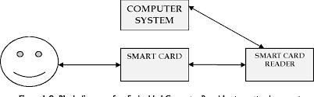

Figure 2.1 Embedded computer-based lecture attendance system

### 2.3.2 Wireless Fingerprint Based College Attendance System Using Zigbee Technology

This system involves the use of fingerprint technology to for attendance marking of students.A fingerprint is made up of a series of ridges and furrows on the surface of the finger (Attendance, 2013). The uniqueness of a fingerprint is determined by the ridges and furrows. Fingerprints are different from one another. Even identifical has different fingerprints which makes fingerprint ideal for identification.

The attendance system is implemented in a class room. Database contains the fingerprint templates of students. The system used fingerprint recognition criteria so proxiew cannot be given. The attendance marking would be done at any place and time because the system was spread over a wide network from classrooms using the internet.

[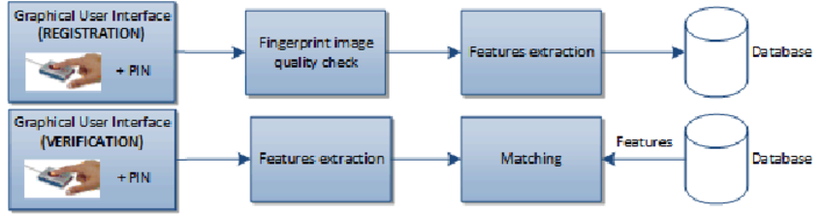](https://www.google.com/url?sa=i&rct=j&q=&esrc=s&source=images&cd=&cad=rja&uact=8&ved=2ahUKEwi484W7lOnaAhWCvRQKHUxgANAQjRx6BAgBEAU&url=https://www.researchgate.net/figure/Simplified-block-diagram-of-biometric-registration-and-verification_fig2_290631465&psig=AOvVaw3W5QgLwFAfGDQu0P53IUYV&ust=1525423709277719)

Figure 2.2 General architecture of fingerprint biometric system

## 2.4 Proposed system

The proposed system for the attendance management system has to be implemented using a barcode technology. The barcode contained on the student ID card is uniquely associated to each student in the University for easy identification. Generally using ID cards has a lot of advantages. One advantage is that it helps fill in class attendance details very fast as compared to using the current system which involves using paper sheet.

The computers that will be used to implement this system have to be connected to barcode readers. The barcode readers come with their own in-built software that will allow the scanner to capture the barcode details. Students will swipe their ID cards onto the barcode reader to fill in their attendance details. The barcode reader will capture the barcode details and store the information in the database.

For the proposed system to work the student has to sign in by using the ID card at the beginning of each class. Each student has their own ID card to fill in their class attendance details. The ID cards the students have must be very accurate in terms of width and darkness so as to ensure that the accurate information is retrieved (Yakub, 2016).

# : Methodology

## 3.1 Introduction

The development methodology approach was Object Oriented analysis and design. The system was developed using Rapid Application Development (RAD). RAD describes a method of software development which emphasizes on rapid prototyping and iterative delivery. A common inclusion in RAD is the use of prototyping. Prototyping is the process of creating prototypes of a software application.

### 3.1.1 Prototyping Model

[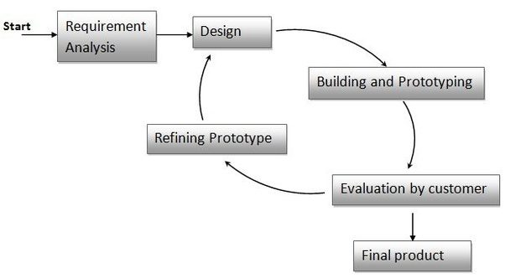](https://www.google.com/url?sa=i&rct=j&q=&esrc=s&source=images&cd=&cad=rja&uact=8&ved=2ahUKEwiOnMLmiOzaAhUCwxQKHeuKDIcQjRx6BAgBEAU&url=https://www.quora.com/What-is-the-prototype-model-When-is-prototype-modelling-used&psig=AOvVaw23mn37nqTn9LGQDJtTP8B5&ust=1525523689946056)

Figure 3.1 Stages of prototyping

### 3.1.2 Stages of prototyping

#### 3.1.2.1 Requirement Analysis

Requirement analysis involves gathering and understanding the very basic requirements needed for developing the produce. The requirements will be acquired through user interaction with the customer.

#### 3.1.2.2 Design

The design phase is implemented when the requirements are already known. The design phase helps in specifying hardware and system requirements and helps in defining the overall system architecture.

#### 3.1.2.3 Design Building and Prototyping

In this phase, user interfaces are provided. This gives same look and feel to the customer in what will be exactly product.

#### 3.1.2.4 Evaluation by Customer

This phase involves taking the developed prototype to the customer and the other stake holders in the project. The customers will evaluate the prototype and give feedback to the system developer.

#### 3.1.2.5 Refining Prototype

Refining prototype phase involves having discussions on the feedback and comments gotten from the customer and having some negotiations with the customer on the time and cost constraints. The changes accepted are again incorporated in the new prototype. The cycle repeats until customer expectations are met.

#### 3.1.2.6 Final Product

After repeating the design, design building and prototyping, evaluation by customer and refining prototype steps, the product is finally developed which meets the customer’s expectations.

### 3.1.3 Justification for using Prototyping Model

The advantage of using prototypes is that it heavily involves the user the users and the system developer discuss what features which might be required and they plan based on those discussions. After the discussion, a rapid prototype is created which the user will interact with so that the user can provide feedback to the system developer.

## 3.2 System Design

### 3.2.1 System Architecture



Figure 3.2 Architecture of the system

### 3.2.2 Flowchart of the System module



Figure 3.3 Proposed System Model

## 3.3 System implementation methods and tools

The Student attendance management system used Xampp application package which allows developers to develop web applications. The package comes with Apache server, and MySQL database.

Apache server is an open source HTTP server(“Purchase: A case study of open source software development: the Apache server,” n.d.) that processes incoming network requests over the HTTPprotocol .MySQL is an open source database management system that allows the user to save large amounts of data to a database.

The programming languages to be used on the back end are PHP. The programming language used on the front end were HTML, JavaScript and CSS. HTML is a standard mark- up language that will be used to create web pages. PHP is a programming language that can be used to connect to MySQL database and manipulate the database. CSS is a style sheet language that deals with how HTML elements are going to be displayed on the screen.CSS will be used to make your web page look more attractive.

## 3.4 Deliverables

**Project Proposal**: It’s a document that approves the project and the goals of the project. It contains three major sections; introduction, literature review and methodology.

**Design and prototype**: It’s a documentation of system designs, these include Entity Relational Diagrams and UML diagrams.

**Testing and final documentation**:documentation is the description of what the system does or will do. It is used to describe system will function. This helps both the system users and in maintenance of the system.

### 

# : System Design and Architecture

## 4.1 Introduction

This chapter involves requirement analysis which involves obtaining function and non-functional objectives. This chapter also involves developing system designs such as Use Case diagram, Sequence diagram, Class diagram and the Entity Relationship Diagram.

## 4.2 Requirement Analysis

### 4.2.1 Functional Requirements

Functional requirements for the project will include;

1. allowing the students to enrol into the system,
2. Enable students to use their barcode in their ID cards to fill attendance details.
3. Enable enrolled students to view their attendance details.
4. Enable lectures to view attendance details of their respective students.
5. Enable the Administrator to view the students and lectures who are in the system.

### 4.2.2 Non-Functional Requirements

#### 4.2.2.1 Usability Requirements

The system will be easy to use and understand. The System will be developed in such a way that is easy for the users to use. The system will be user friendly in the sense that it uses a graphical user interface.

#### 4.2.2.2 Performance Requirements

The system will enable easy and fast retrieval of information from the database. The student will easily interact with it.

#### 4.2.2.3 Supportability Requirements

The web-based system will be used in computers. The computer must be connected to the internet for the system to work efficiently.

## 4.3 System Designs

### 4.3.1 Use Diagram



Figure 4.1 Student Attendance Management system

#### 4.3.1.1 Actor Roles

##### 4.3.1.1.1 Administrator

The administrator functionalities include:

* Login into the system
* Creating an account for the lecturers
* Creating an account for the students
* Adding a new unit to the system

##### 4.3.1.1.2 Lecturer

The Lecturer functionalities include;

* Login into the system
* View the units assigned to them by the Administrator
* View student attendance details for their respective students

##### 4.3.1.1.3 student

The student functionalities include:

* Login in the system
* Enrolling for a unit
* Filling attendance details using a barcode on student ID cards for a particular unit
* Viewing attendance for a unit

### 4.3.2 Sequence Diagram

Figure 4.2 Sequence Diagram

### 4.3.3 Database Schema

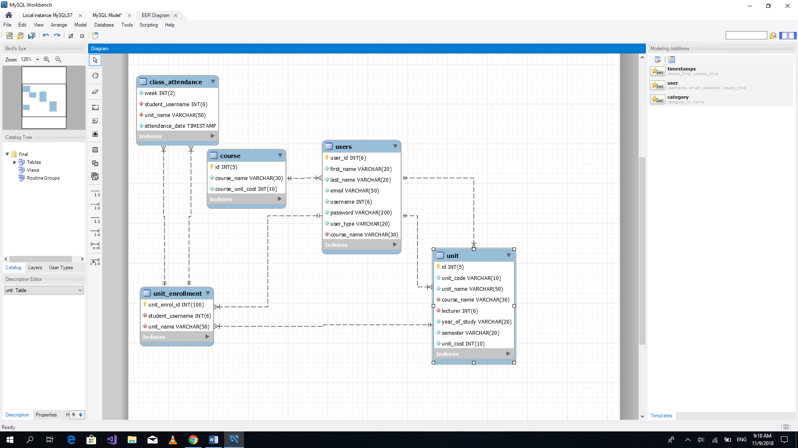

Figure 4.3 Database Schema

### 4.3.4 Design ERD Diagram



Figure 4.4 Entity Relationship Diagram

### 4.3.5 Design Class Diagram

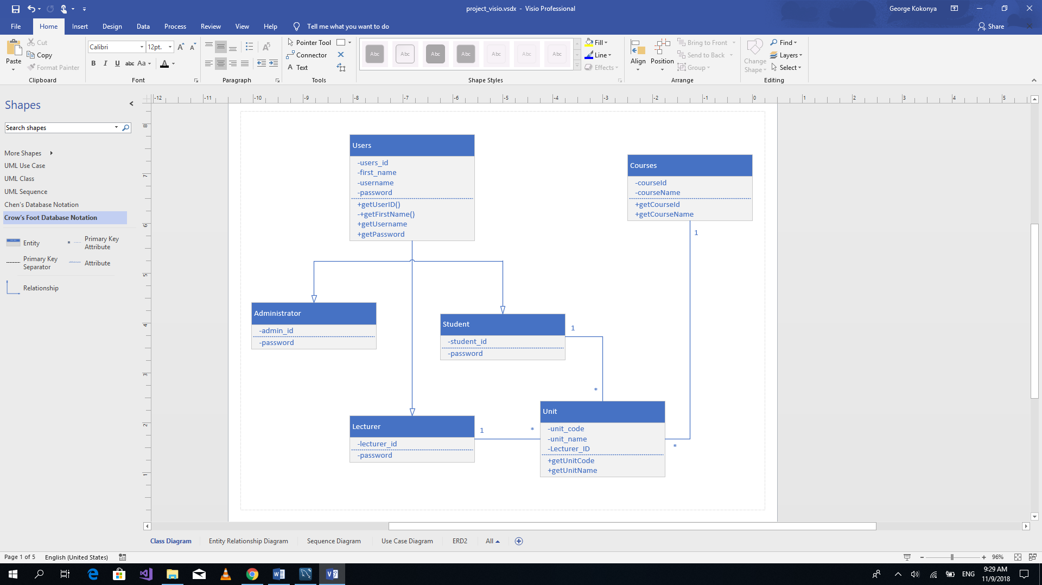

Figure 4.5Class Diagram

## 4.4 Proposed System Architecture



Figure 4.6 System Architecture

# : System Development, implementation and Testing

## 5.1 Introduction

This chapter involves system testing and implementation and testing of the attendance management system using barcode identification.

## 5.2 System Development

The application comprises of the front-end and backend subsystem. The front-end subsystem was implemented using Hypertext Mark-up Language (HTML) while the back-end subsystem Hypertext Pre-processor (PHP). HTML was used to provide and interface where by barcode details would be entered while PHP was used to send the barcode data in to MySQL database. MySQL database was used because it is compatible with PHP and it is open source.

## 5.3 System Implementation

The system was implement using a barcode reader, student Identification card and a web-based application. The barcode reader enabled capturing of barcodes from Student identification cards. The barcodes collected would then be stored in a database.

### 5.3.1 barcode reader

Cameras on android smart phones were used as barcode readers or scanners. Barcode Scanner applications can be downloaded to be used as scanners

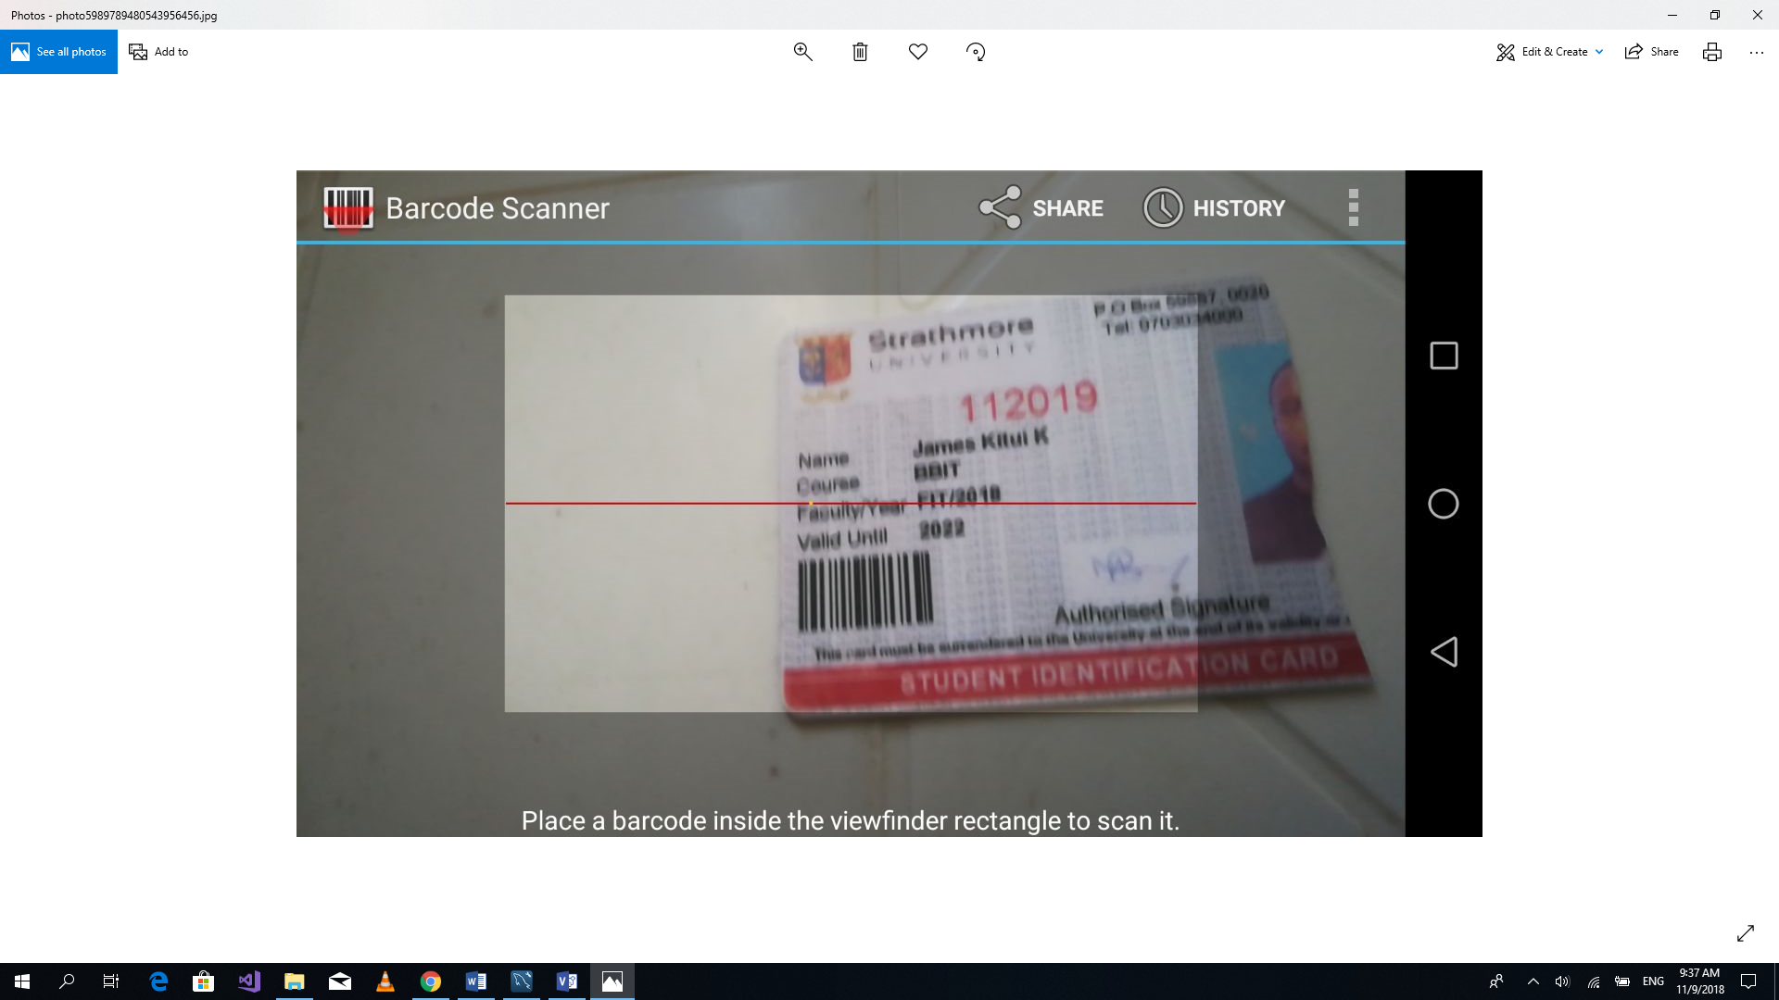

Figure 5.1 Barcode reader android application

### 5.3.1 Web Application

The web application has three users. The users include an administrator, a student and lecturer. The administrator is the only user who can register a student and a lecturer. After being registered the student and lecturer can then access the web application by the using their login credentials. The Web application generates for a list of students, courses, lecturers and units. The Reports can be downloaded in PDF format by authorised users.

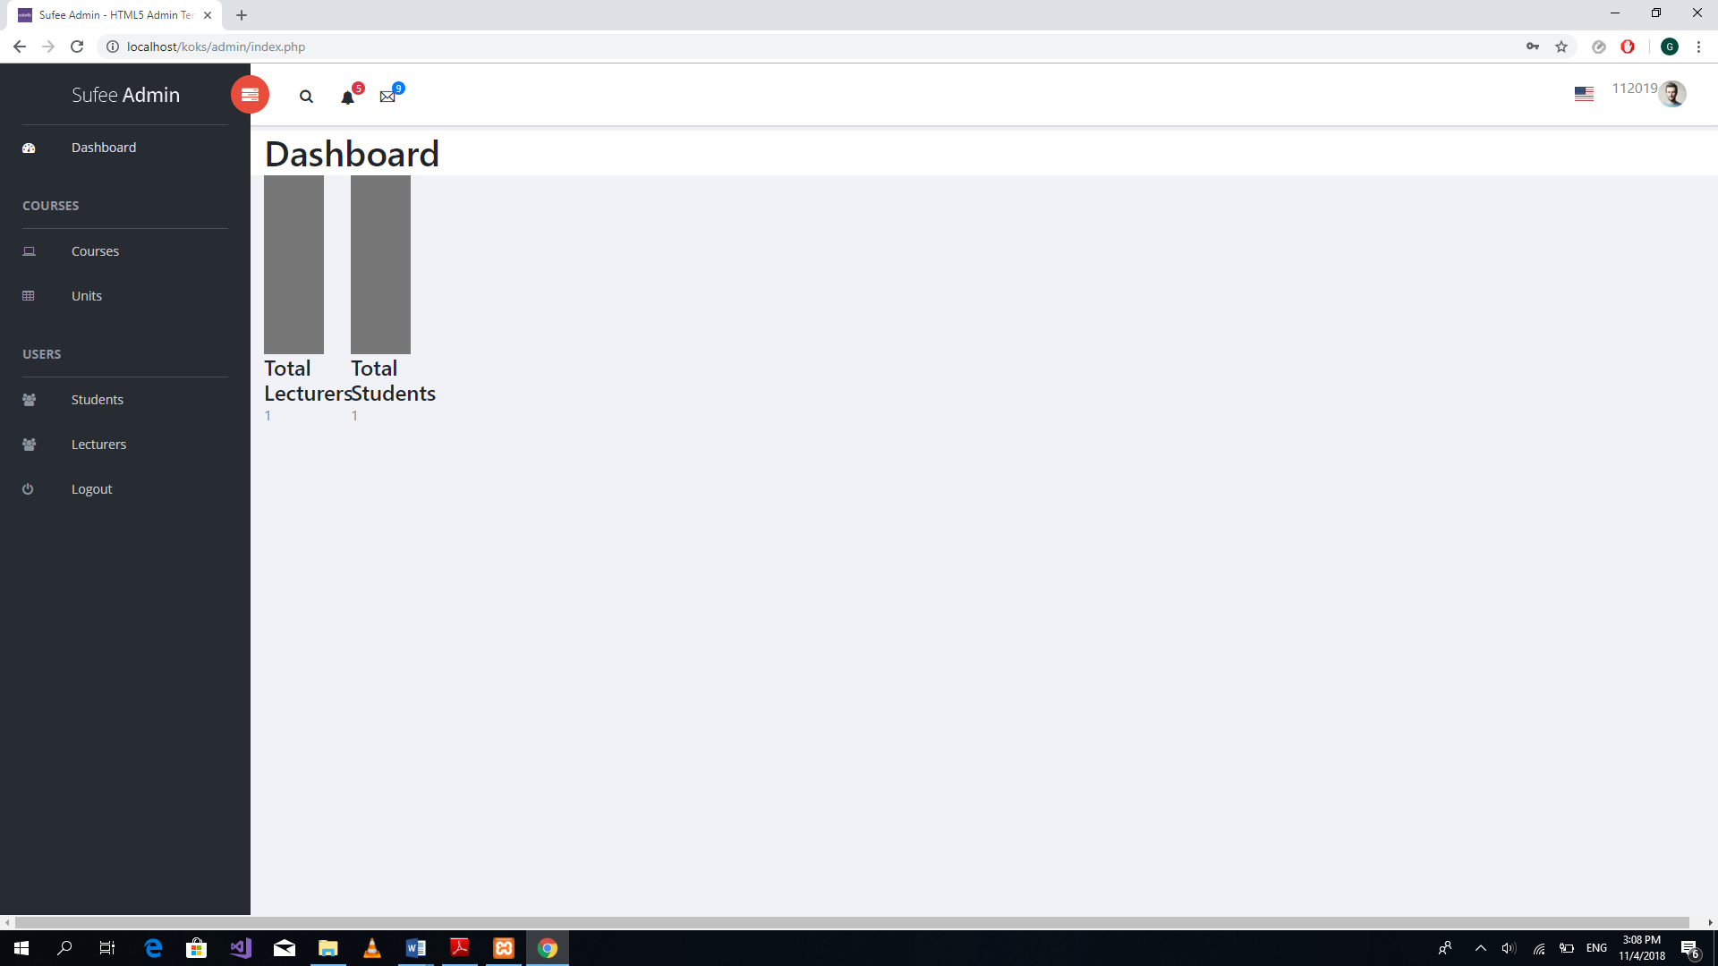

Figure 5.2 Administrator Homepage

## 5.4 System Testing

system testing in general were performed on the system. The purpose of this test is to evaluate the system's compliance with the specified requirements.

### 5.4.1 Test Environment

|  |  |  |  |
| --- | --- | --- | --- |
|  | **Server-side specifications** | **Client-side specifications** | Network specifications |
| Operating System | Windows 10 | Windows 10 |  |
| Speed | 2.2GHz | 2.2GHz |  |
| Processor | Intel CORE i3 5th Generation and above | Intel CORE i3 5th Generation and above |  |

Table 5.1 Test Environment

### 5.4.2. Test Cases

The table below lists a set of test cases performed on the system to checks its functional and non-functional requirements.

|  |  |  |  |  |  |
| --- | --- | --- | --- | --- | --- |
| **Test ID** | **Related requirement** | **Inspection check** | **Pre-condition** | **Test data** | **Priority level** |
| M1 | (function)  An administrator should be able to create a course | Does the system allow the administrator to create a course? | There should be internet connection |  | High |
| M2 | (functional)  An administrator should be able to create a unit | Does the system allow the administrator to create a unit? | There should be internet connection |  | High |
| M3 | (functional)  An administrator should be able to register a student into the system | Does the system allow the administrator to register a student? | There should be internet connection |  | High |
| M4 | (functional)  An administrator should be able to register a lecturer into the system | Does the system allow the administrator to register a lecturer? | There should be internet connection |  | High |
| M5 | (functional)  An administrator should be able to view students registered into the system | Does the system allow the administrator to view students? | The details of the student should be available in the database |  | High |
| M6 | (functional)  An administrator should be able to view lecturers registered into the system | Does the system allow the administrator to view lecturers? | The details of the lecturer should be available in the database |  | High |
| M7 | A student should be able to register for a unit | Does the system allow the student to register a unit? | The student should be registered into the system |  | High |

Table 5.2 Test Cases

### 5.4.3 Test results

|  |  |  |  |  |
| --- | --- | --- | --- | --- |
| **Test ID** | **Expected result** | **Actual result** | **Status** | **Remarks** |
| M1 | The administrator to be able to insert a new course into the system | The administrator successfully added a new course | Success | In case of failure inserting unit details, check on the validity of the data submitted. |

Table 5.3 Test Result for Test ID M1

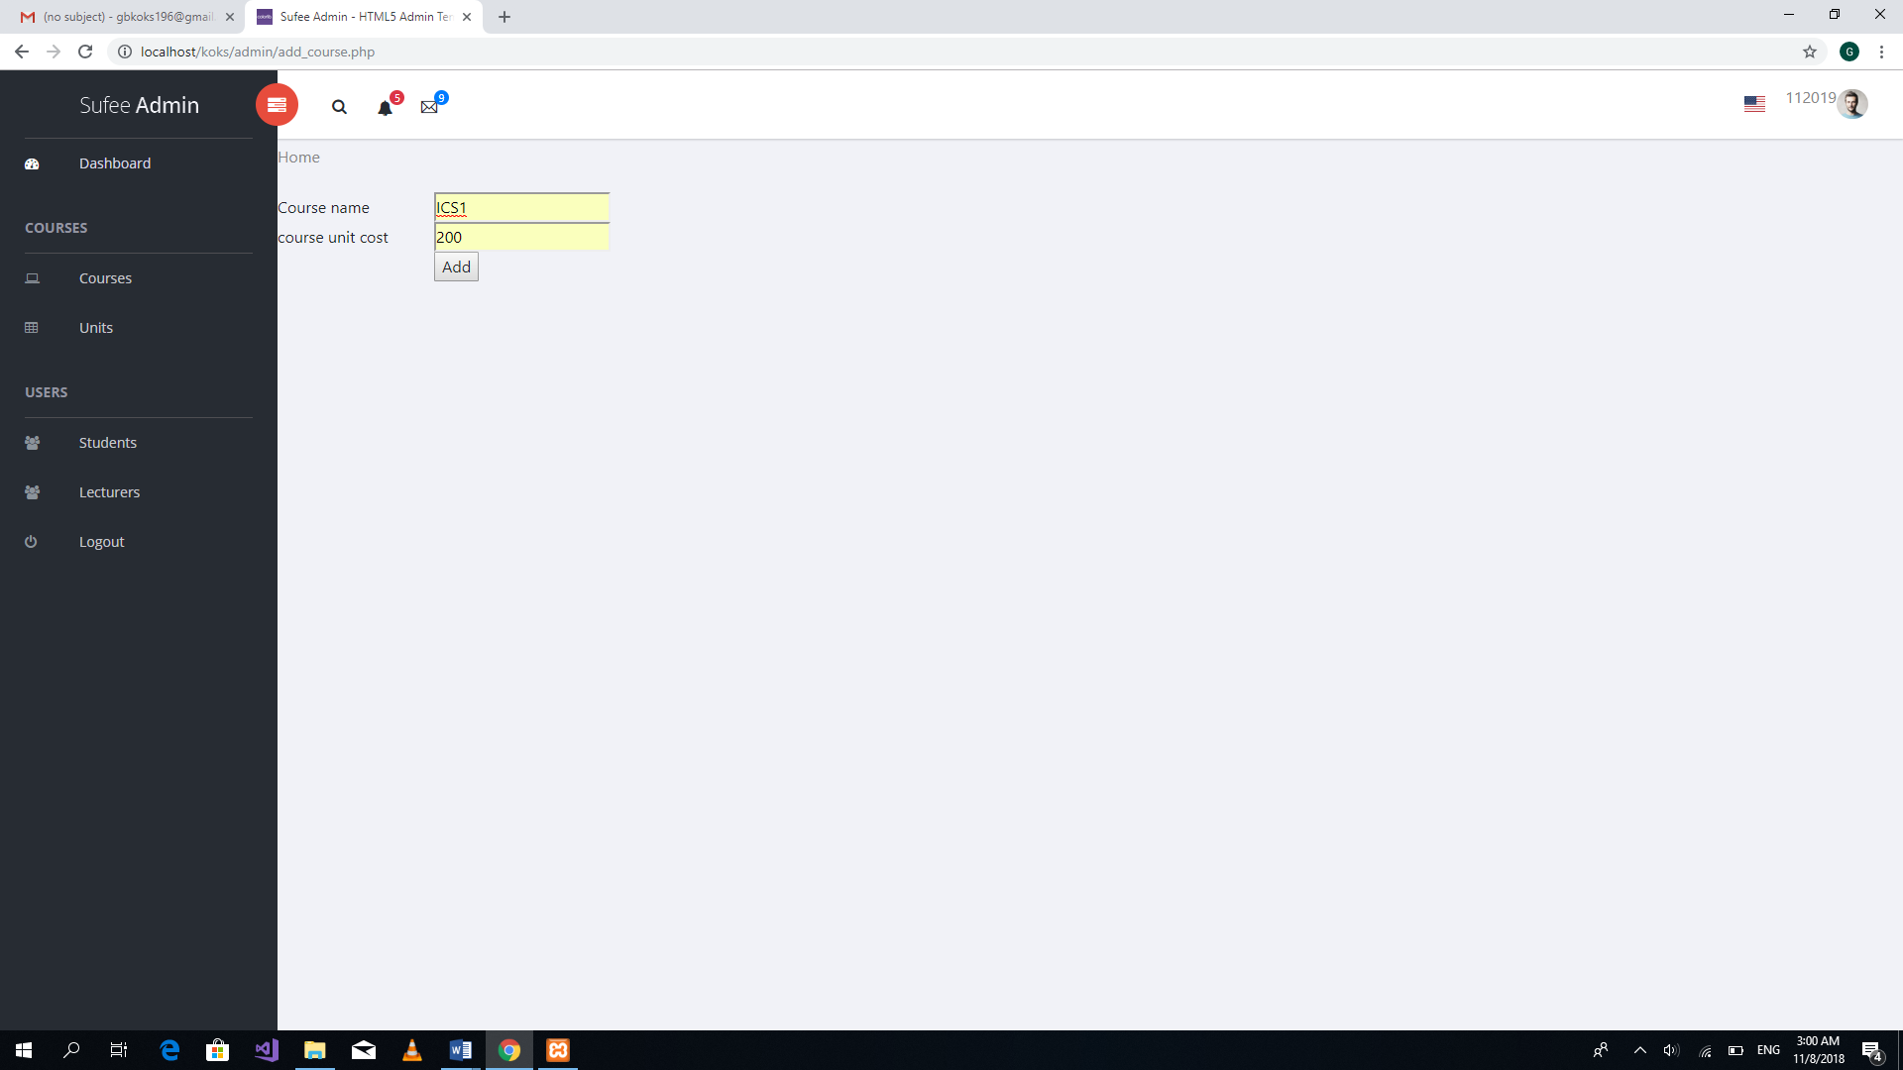

Figure 5.3 Test Result for Test ID M1

|  |  |  |  |  |
| --- | --- | --- | --- | --- |
| **Test ID** | **Expected result** | **Actual result** | **Status** | **Remarks** |
| M2 | The administrator to be able to insert a new unit into the system | The administrator successfully added a new unit | Success | In case of failure inserting unit details, check on the validity of the data submitted. |

## 

Table 5.5 Test Result for Test ID M2

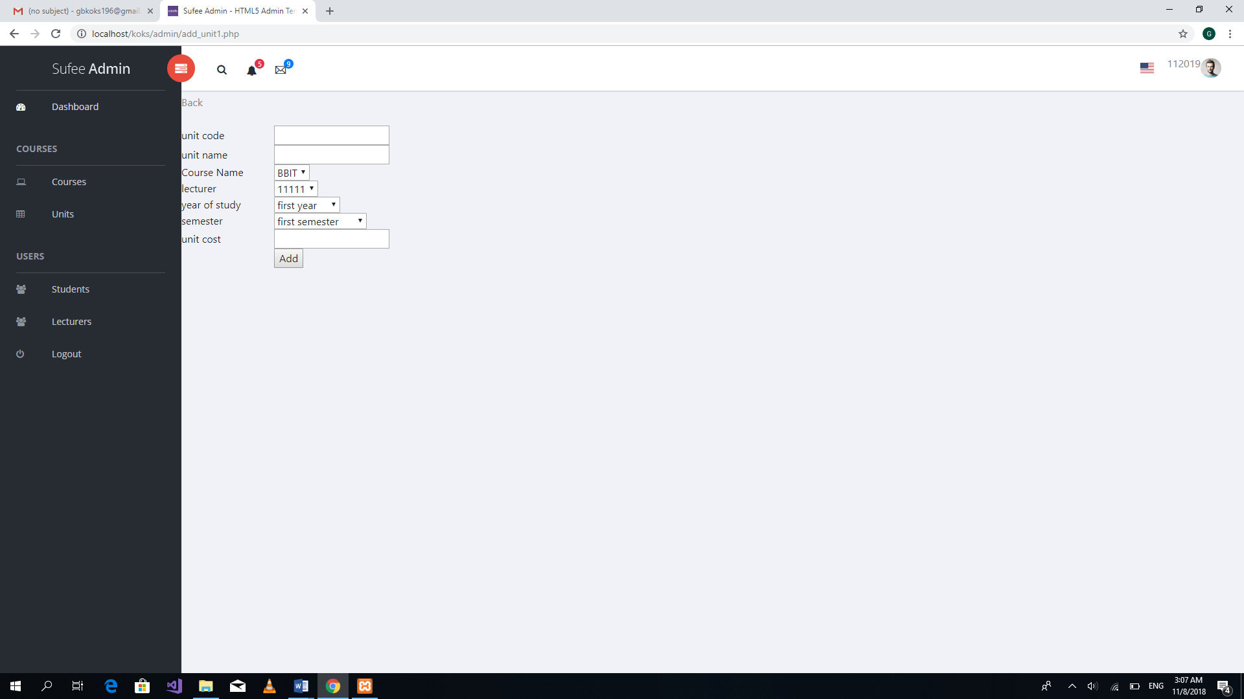

Figure 5.4 Test Result for Test ID M2

|  |  |  |  |  |
| --- | --- | --- | --- | --- |
| **Test ID** | **Expected result** | **Actual result** | **Status** | **Remarks** |
| M3 | The administrator to be able to insert a student into the system | The administrator successfully added a student | Success | In case of failure inserting student details, check on the validity of the data submitted |

Table 5.6 Test Result for Test ID M3

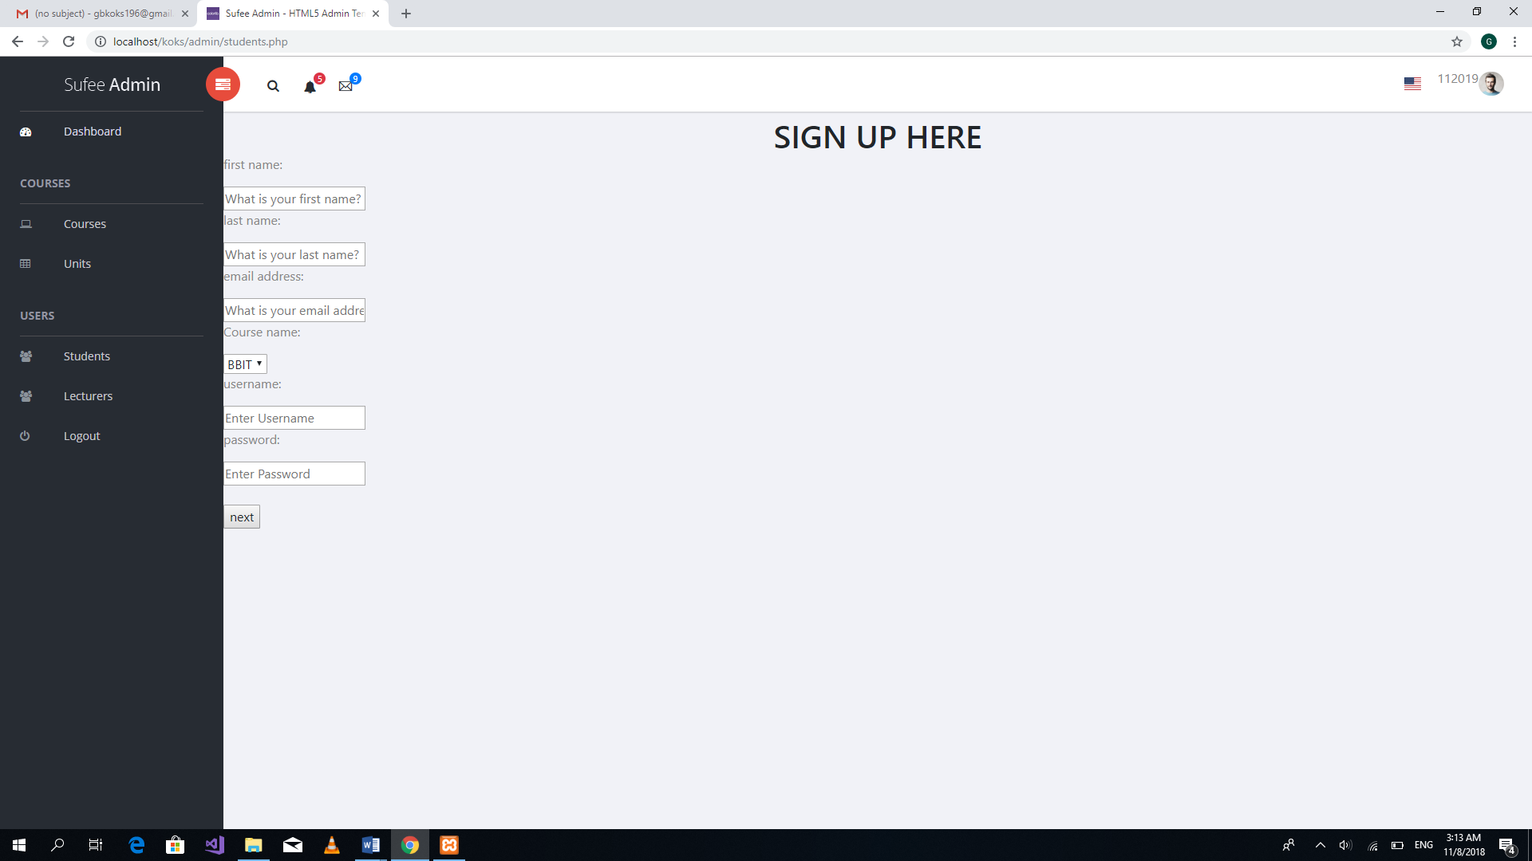

Figure 5.5 Test Result for Test ID M3

|  |  |  |  |  |
| --- | --- | --- | --- | --- |
| **Test ID** | **Expected result** | **Actual result** | **Status** | **Remarks** |
| M4 | The administrator to be able to insert a lecturer into the system | The administrator successfully added a lecturer | Success | In case of failure inserting lecturer details, check on the validity of the data submitted. |

Table 5.7 Test Result for Test ID M4

## 

Figure 5.6 Test Result for Test ID M4

|  |  |  |  |  |
| --- | --- | --- | --- | --- |
| **Test ID** | **Expected result** | **Actual result** | **Status** | **Remarks** |
| M5 | The administrator to be able to view student details | Student details were successfully displayed | Success | In case of a fail, the internet connection should be checked, otherwise it should function effectively |

Table 5.8 Test Result for Test ID M5

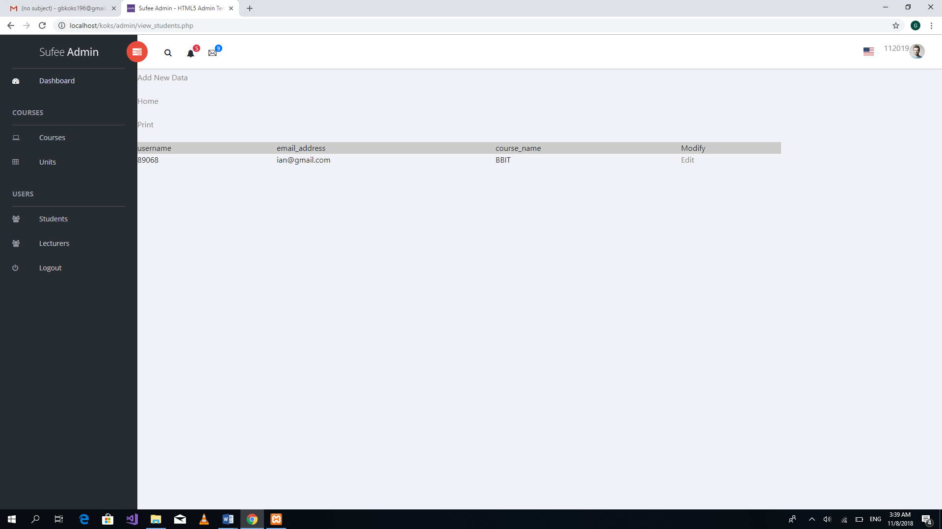

Figure 5.7 Test Result for Test ID M5

|  |  |  |  |  |
| --- | --- | --- | --- | --- |
| **Test ID** | **Expected result** | **Actual result** | **Status** | **Remarks** |
| M6 | The administrator to be able to view lecturer details | Lecturer details were successfully displayed | Success | In case of a fail, the internet connection should be checked, otherwise it should function effectively |

Table 5.9 Test Result for Test ID M6

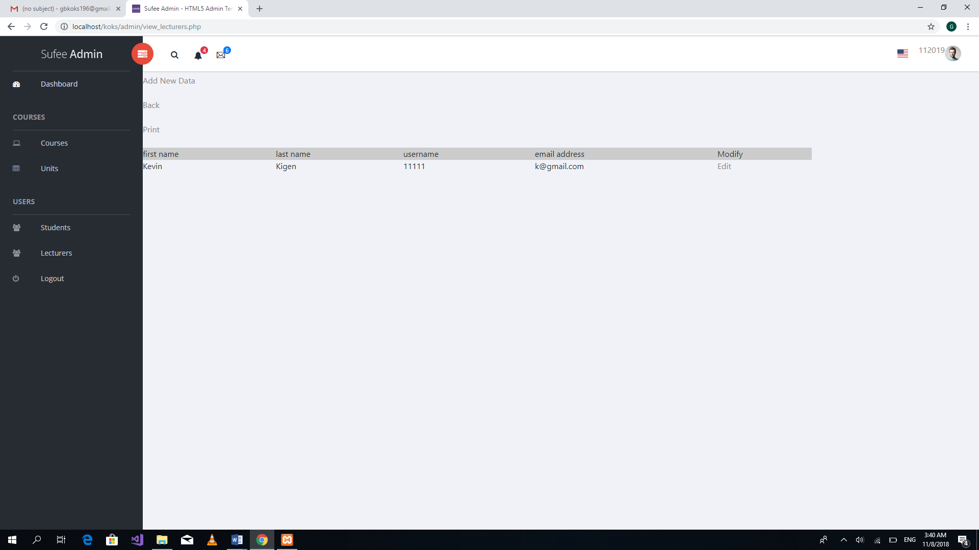

Figure 5.8 Test Result for Test ID M6

|  |  |  |  |  |
| --- | --- | --- | --- | --- |
| **Test ID** | **Expected result** | **Actual result** | **Status** | **Remarks** |
| M7 | The student to be able to register for a unit | The student successfully registered for the unit | Success | In case of a fail, the internet connection should be checked, otherwise it should function effectively |

Table 5.10 Test result for Test ID M7

## 

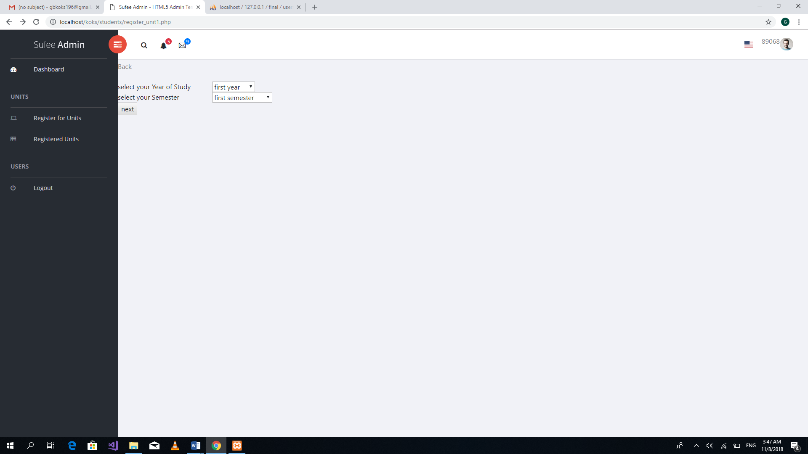

Figure 5.9 Test result for Test ID M7

## 5.5 System Outcomes

The system was able to achieve the main of objective the main objective which was to use a barcode reader to capture barcode on student identification cards. The information captured by the barcode reader would be used to fill student attendance details. Another outcome was that the system was able to generate a list of students who have system into the system and also a list of students who have enrolled for a particular class.

# : Conclusion and Recommendation

## 6.1 Conclusion

The main Objective of the project was to develop a web-based attendance management system. The system was to implement a barcode code reader that reads barcodes on student Identification cards. The barcodes used would be captured using a barcode reader and stored in a database to mark that a student attended class.

## 6.2 Recommendations

The student attendance management system using barcode identification should be hosted in an online and secure web server. The system also requires an environment with good internet connections which will enable sending and retrieving of data from database within a short period of time.

## 6.3 Future Works

Most of the functionalities in the system were achieved successful but there is still more do be done. The key areas that need improvement is making the system get the attendance of a student. The system is not able to calculate the attendance for a single student in terms of percentage

The system can also be improved by making it a cross platform application. This is where by the system will be able to operate in multiples platforms. For example, the system will be compatible with creating android applications and online web application. Having the system on an android application makes easy for lecturer to monitor student attendance for a particular unit.

Another improvement that can be made is improving the user interface so that it can be more appealing to the users. A well-designed user interface that the system more user friendly and easy to use.

# APPENDICES

## APPENDIX 1: Administrator User Manual

1. The Administrator has to login

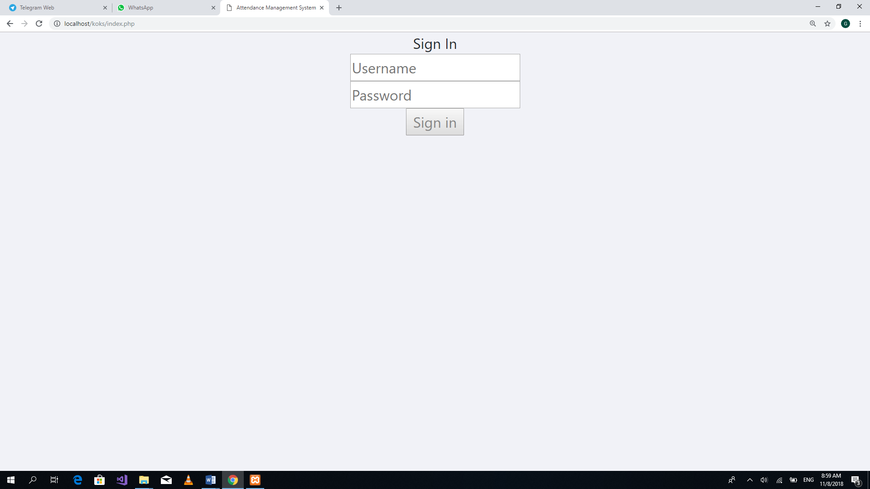

Figure Appendix 1 Administrator Login

1. Click on Add new Data to register a lecturer

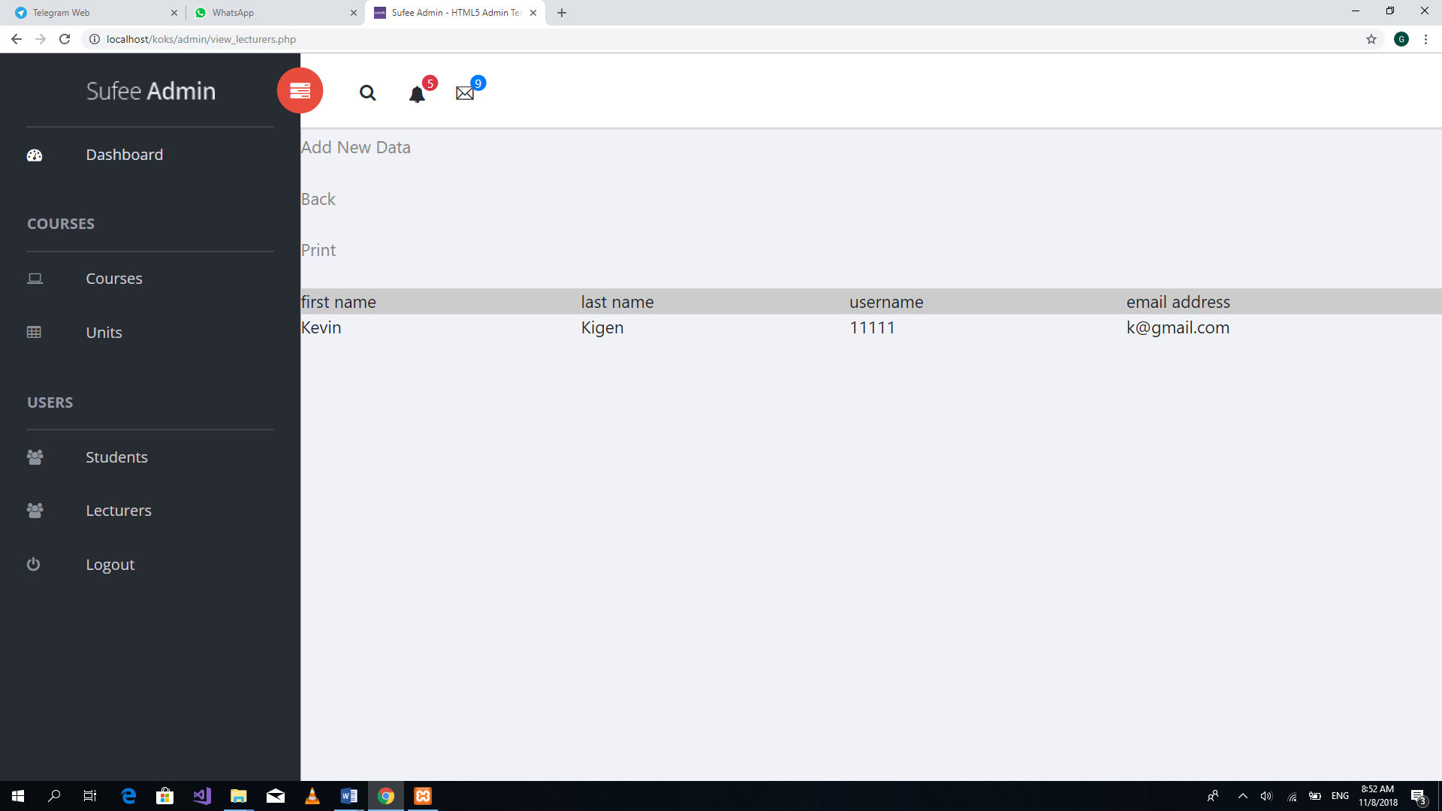

Figure Appendix 2 Administrator registering lecturer to system

1. Add lecturer details and then click add

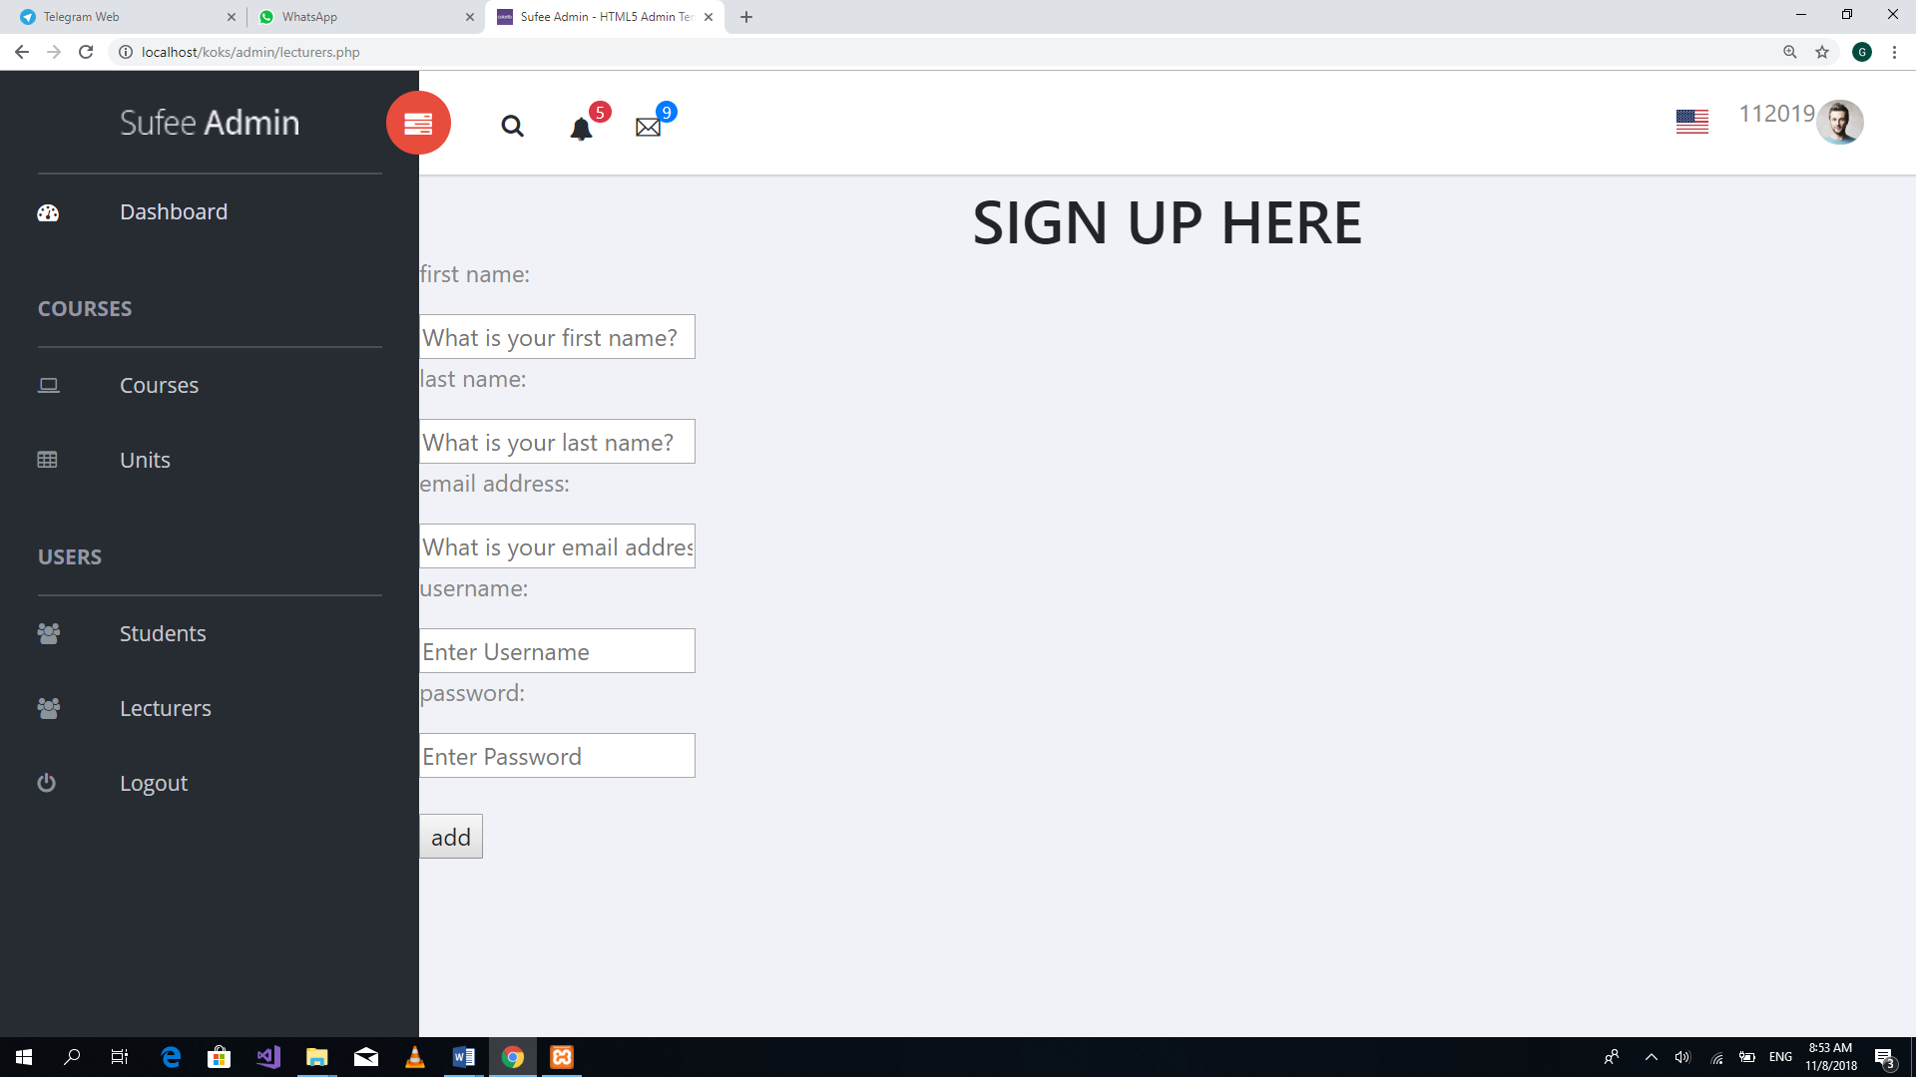

Figure Appendix 3 clicking add to submit form

1. Click on Students than click on Add New Data to register a student into the system

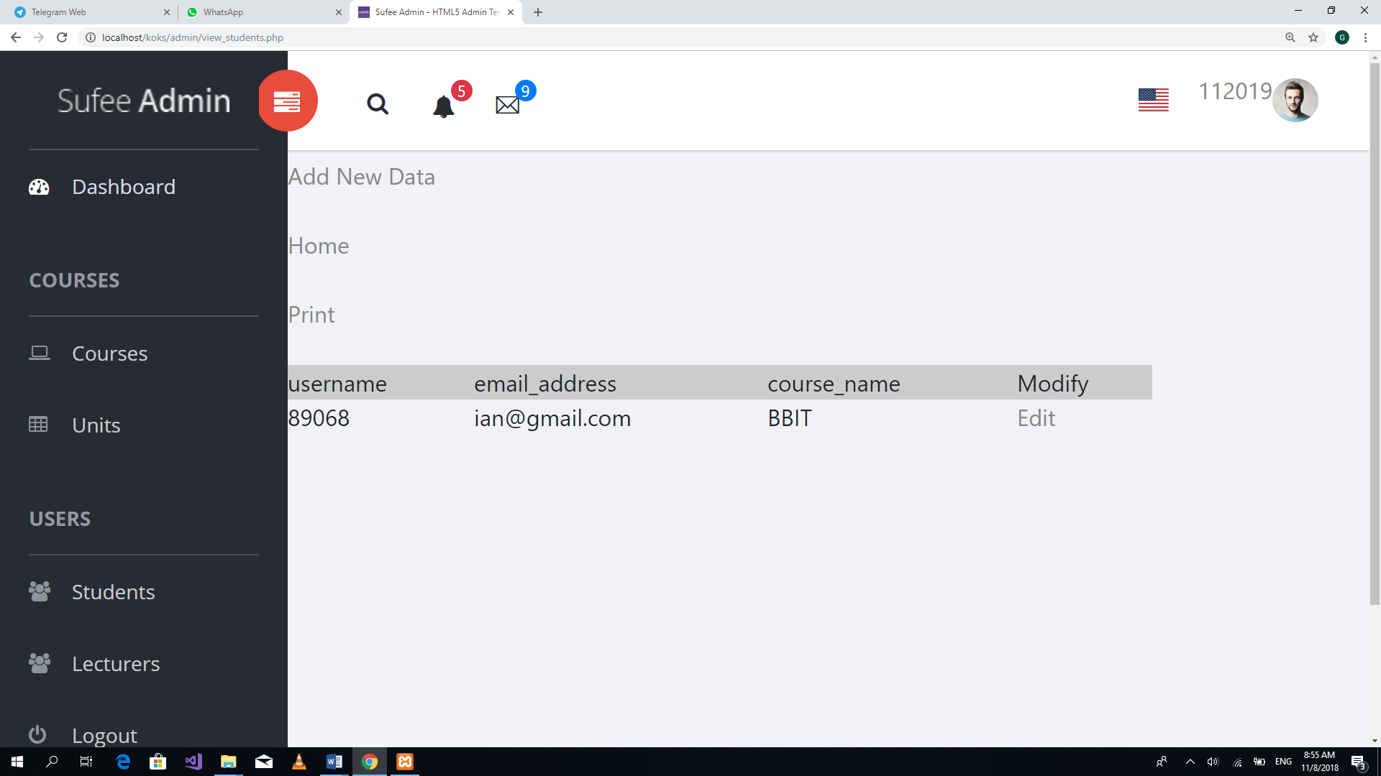

Figure Appendix 4 Registering student to system

1. Fill in the student details and click next to finish student registration

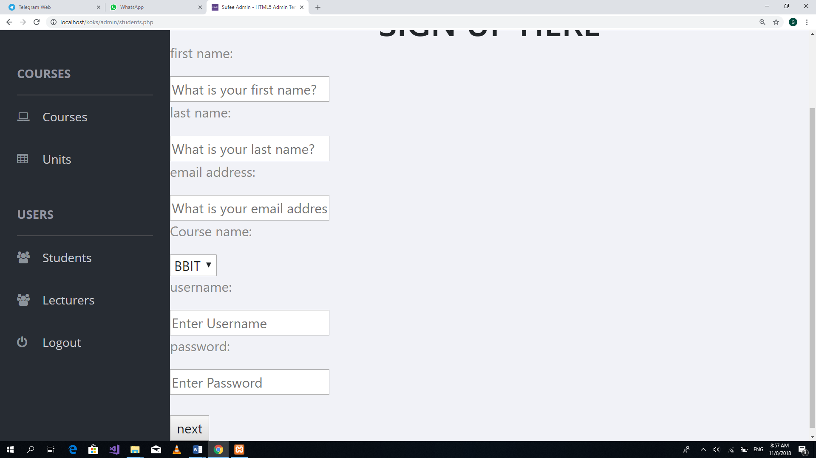

Figure Appendix 5 submitting student form

1. Click logout

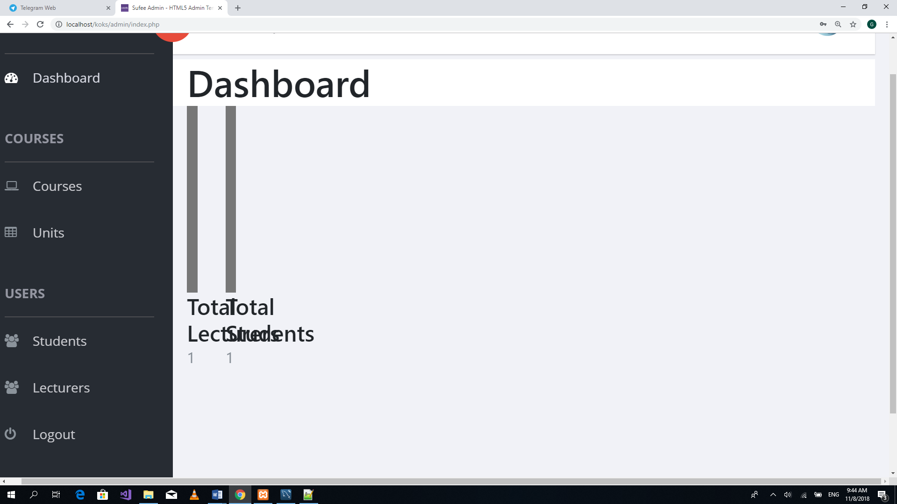

Figure Appendix 6 Administrator logging out of the system

## APPENDIX 2: Student User Manual

1. Enter credential and click signing as a student

Figure Appendix 7

1. Click on register for unit. Then select the student year of study and semester and click on next

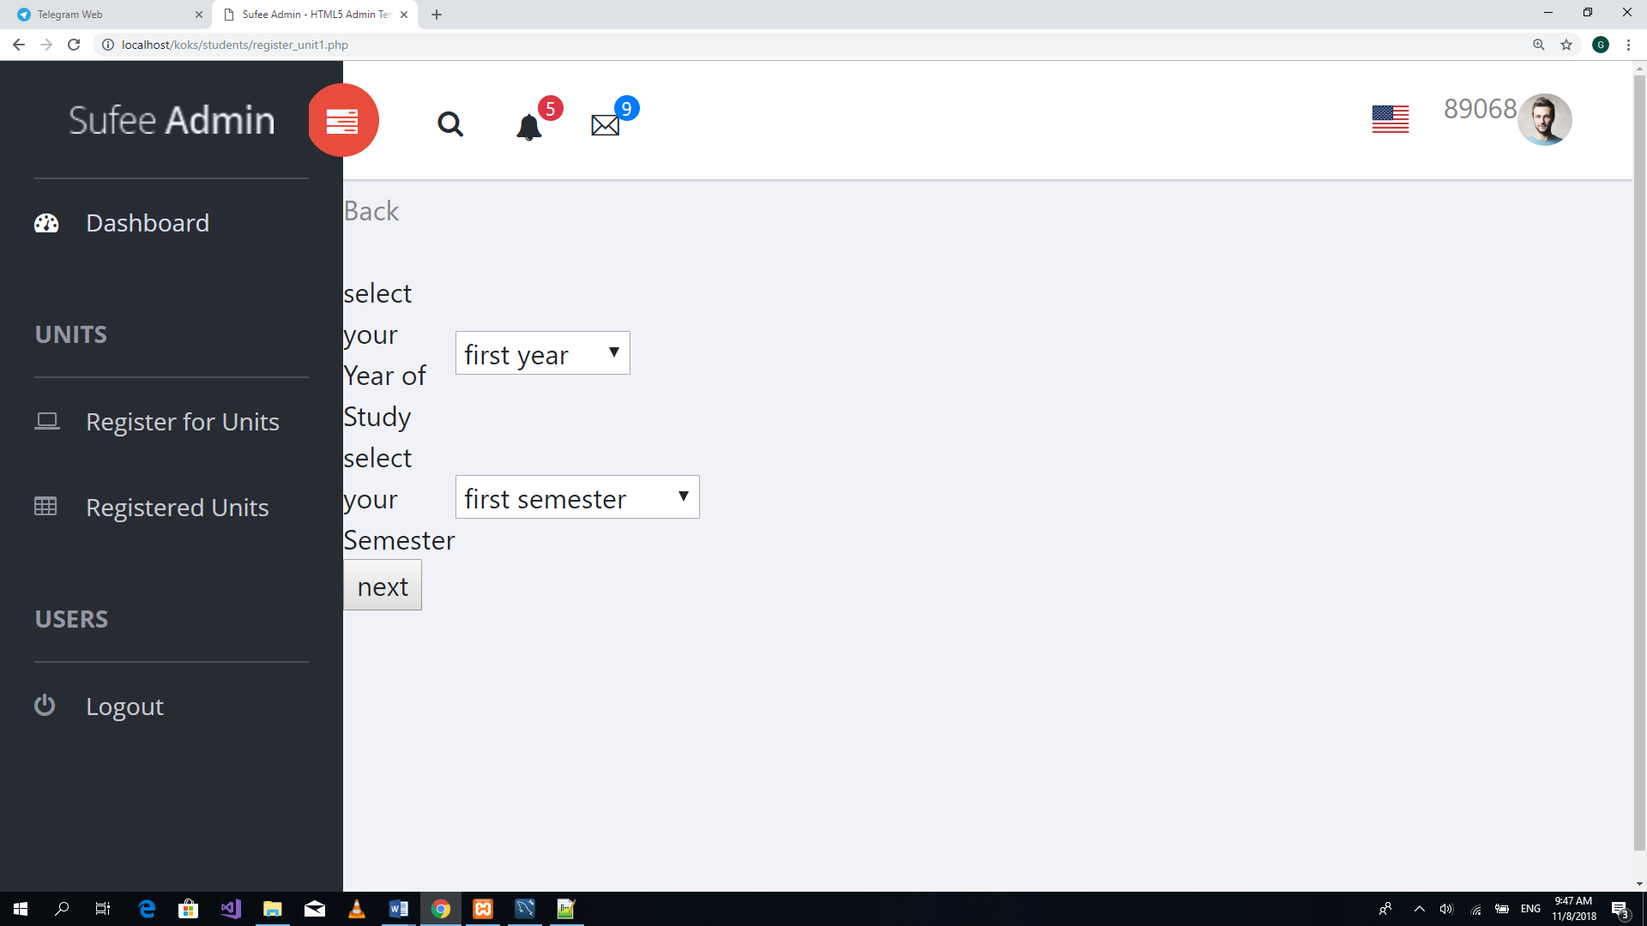

Figure Appendix 8

1. Choose the unit you want to register by clicking Register. Then click on Registered units to view the registered units

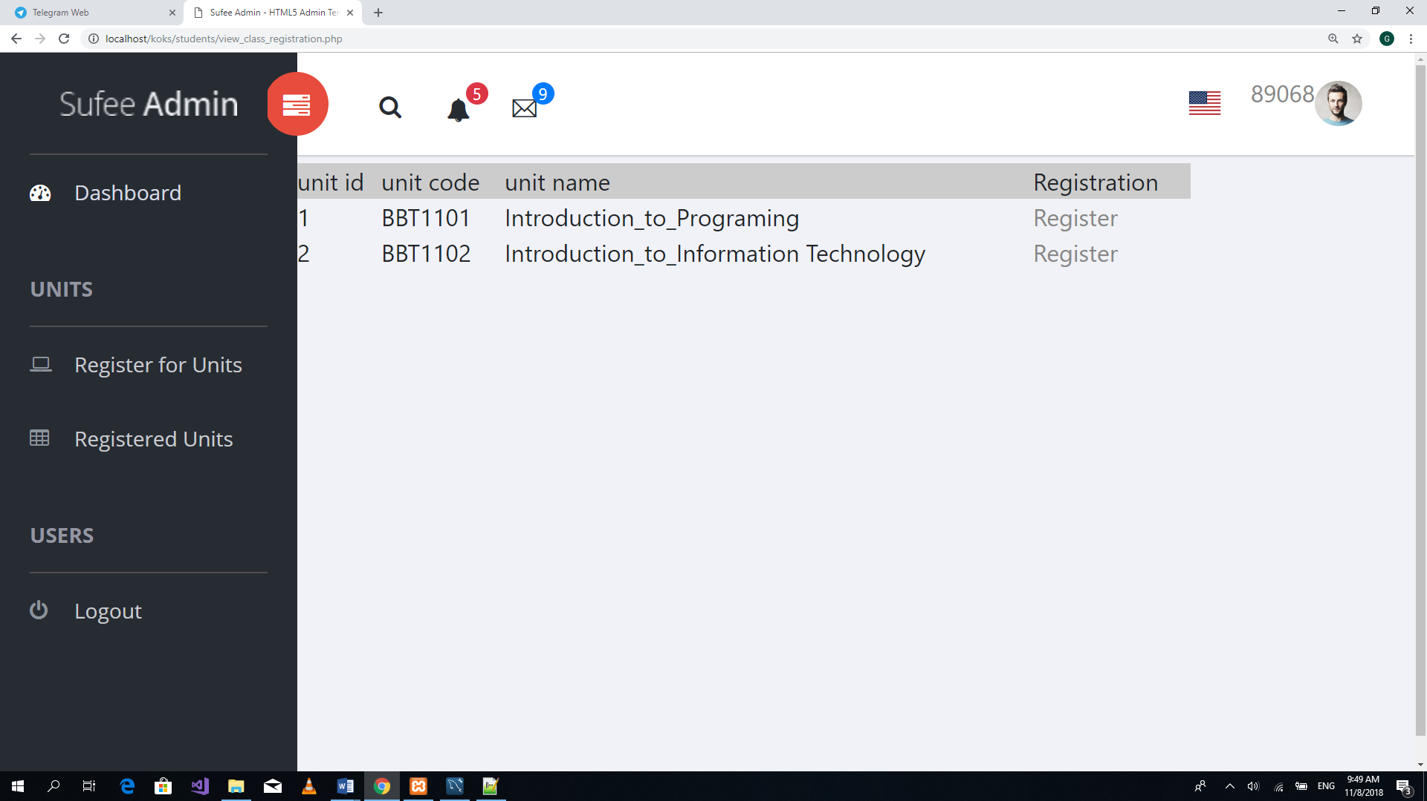

Figure Appendix 9 Unit enrolment

1. Display of registered units

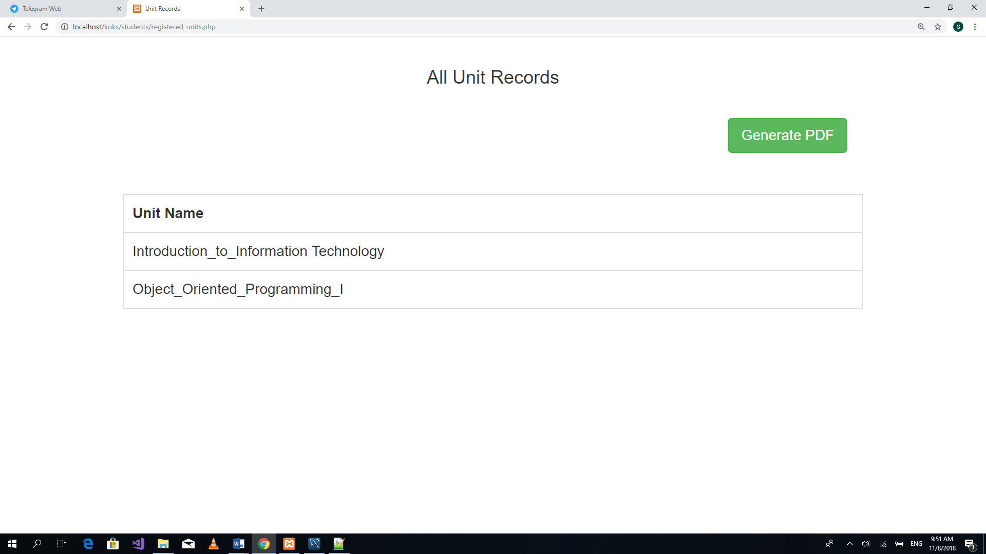

Figure Appendix 10 List of registered units for a student

1. Click Logout

Figure Appendix 11 logging out of student homepage

## APPENDIX 3: Lecturer User Manual

1. Enter credential and login as a Lecturer



Figure Appendix 12 Login with Lecturer credentials

1. Click on Attendance to create class session

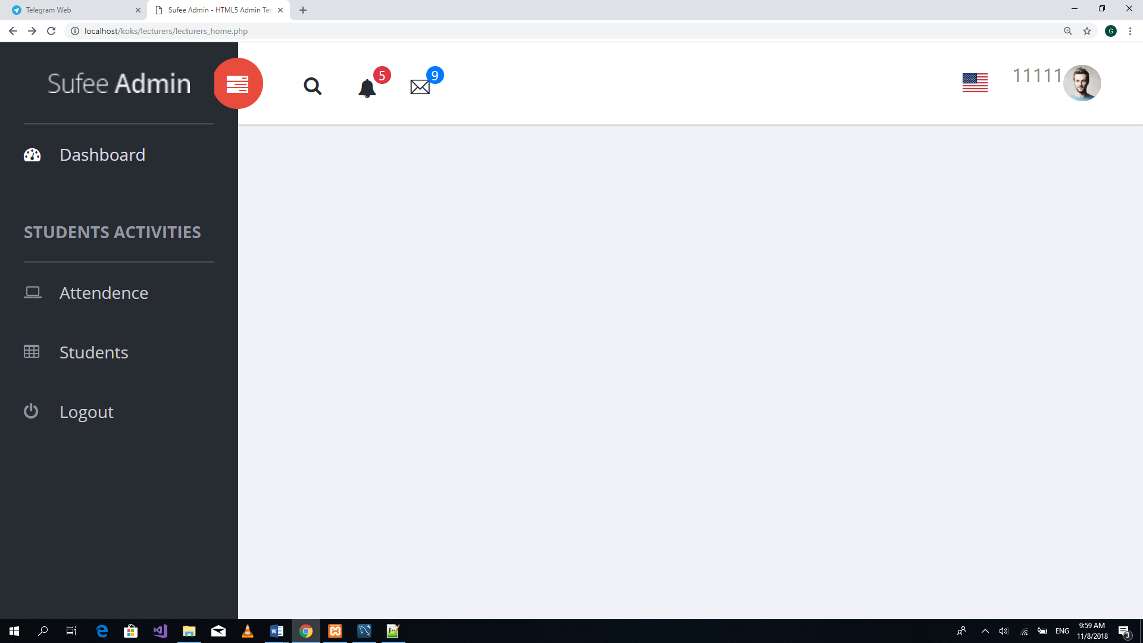

Figure Appendix 13 Lecturer homepage

1. Select a unit from the list of options and enter the week for creating the class.

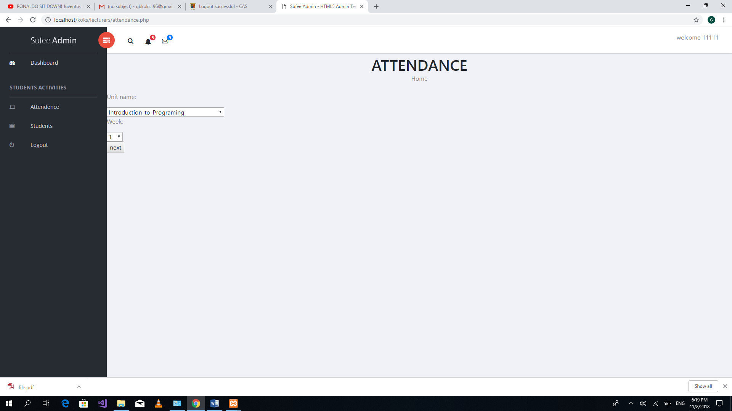

Figure Appendix 14 creating class session

1. Use the barcode scanner and capture the student barcode on student identification card

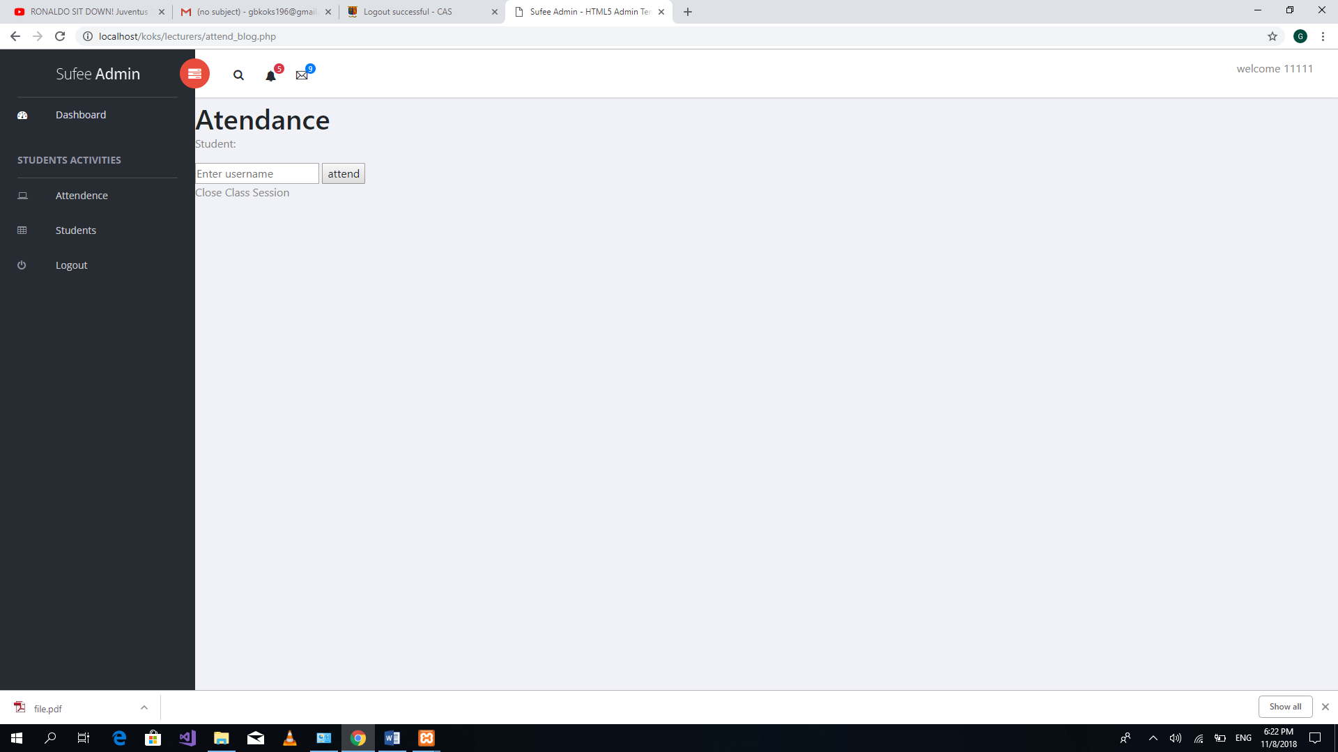

Figure Appendix 15 filling student attendance

1. Click on Students to view student attendance details



Figure Appendix 16 Lecturer Homepage

1. Select a particular unit. Then Click on check student to view student attendance for a particular unit

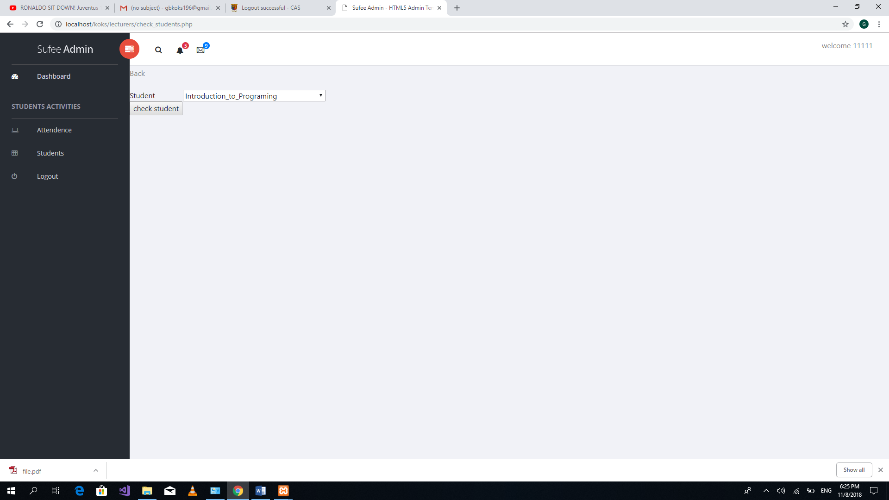

Figure Appendix 17 Viewing student attendance

# References

(2018, April 19). Retrieved from Internet World Stats: https://www.internetworldstats.com/stats1.htm

Attendance, W. F. (2013). Wireless Fingerprint Based College Attendance.

O. Shoewu. (2014). Embedded Computer-Based Lecture Attendance.

*Strathmore University-Leading Private Non-Profit Unversity in East Africa*. (n.d.).

*Techopedia*. (n.d.). Retrieved from https://www.techopedia.com/definition/1726/electronic-card-e-card

*TEC-IT*. (2018, 4 27). Retrieved from https://www.tec-it.com/en/download/data-acquisition/twedge/Download.aspx

Yakub, S. (2016). Attendance Management System Using Barcode Identification on Students' Identity Cards.